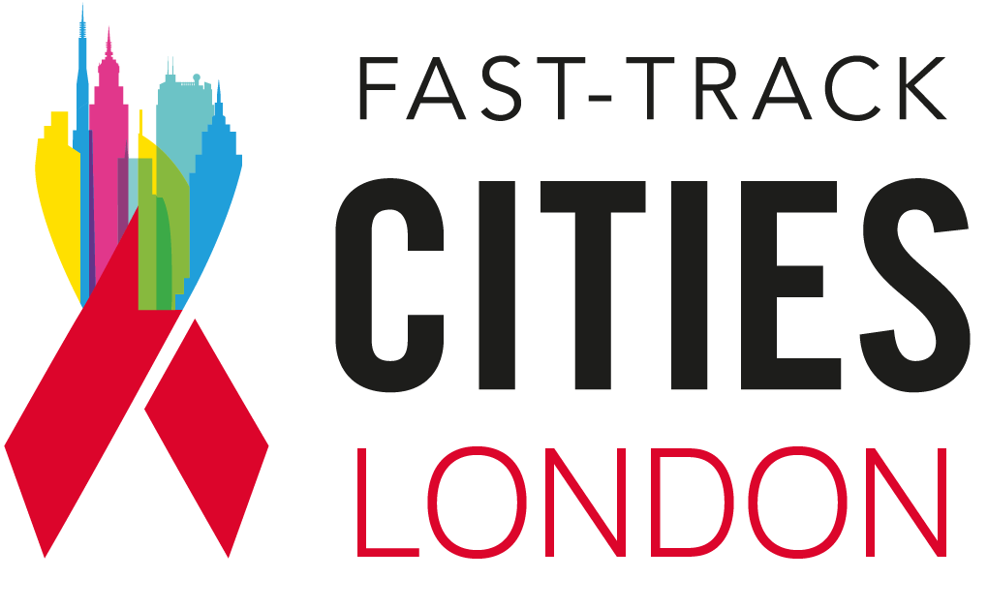

Re-engagement in care funding grant application form
January – February 2026
Please submit by Thursday 12 February at 5pm.
Email any questions to maria.vidal-read@nhs.net

Application form
- Your name, organisation and contact details (email and phone)
- Which organisations are in your partnership?
- How will you deliver on the objectives?
- Give a breakdown of the grant funding and how the funding will be used?
- What area of London will you be covering and what expertise do you have in that area?
- What risks have you identified and how will you mitigate those risks?

For more information about this grant please visit the dedicated web page at: https://fasttrackcities.london/funding-opportunity-re-engaging-londoners-living-with-hiv-back-into-care/

