
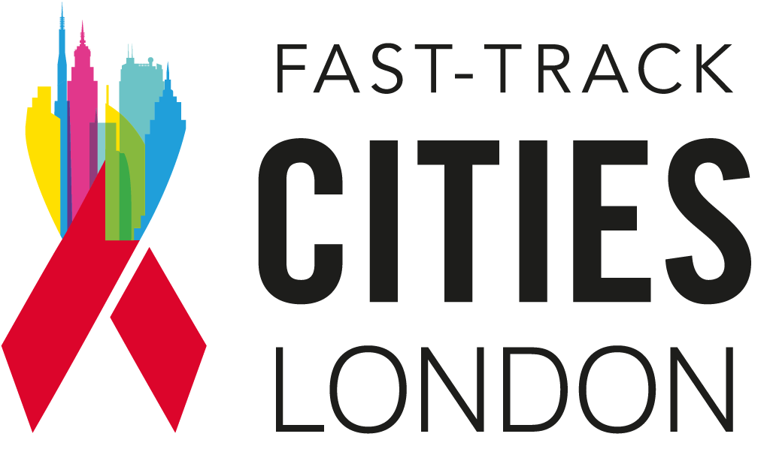

World AIDS day 2025

Communications toolkit

About
In the weeks around World AIDS Day, the Do It London campaign is focusing on two key messages:
- Talking about sexual health & HIV is a part of dating
- London can end new HIV transmissions

Visual assets
Images can be downloaded from Fast- Track Cities London’s website:
- Facebook/Instagram
- Twitter
Videos:
- A play list of the short videos in various resolutions is available share or embed from YouTube: WorldAIDSDay playlist
- or email maria.vidal-read@nhs.net for original mpg files.

Posts

2 topics, text for and images
Dating and sexual health 2
Testing, Protecting and Preventing (General) 5

Posts
Hashtag: #WorldAIDSday

Dating and sexual health

Channel | Post | Static image / Video link
X / Twitter | Rebecca and Chisea chat dating, confidence & knowing your status.  Rebecca flips the script — she knows her status. Do you know yours?  Watch their chat then book your test this #WorldAIDSDay  👉 TOSD.shl.uk | 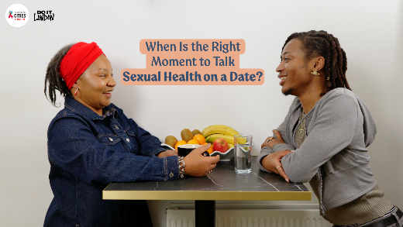  https://youtu.be/TrbGHgibIL4?si=zgsu4cq4s7w9O7CF
FB/Instagram | Rebecca and Chisea swap stories about dating and sexual health.  Rebecca, who’s living with HIV, flips the script — she knows her status, and that gives her power.  It’s the other person who might need to catch up.  This World AIDS Day, we’re celebrating conversations that challenge stigma and put sexual health front and centre.  Because confidence starts with knowing your status.  🎥 Watch now to hear their takes.  And to book your free HIV test today, follow the link in our bio.  #WorldAIDSDay #DoItLondon #HIVAwareness #SexualHealthMatters #KnowYourStatus | 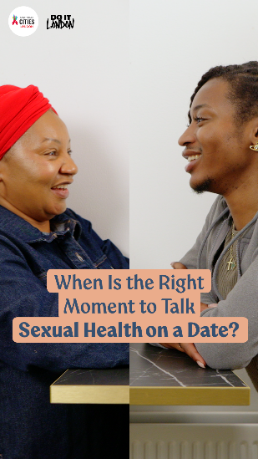
X / Twitter | “If you’re interested, you’ll do the homework.”  Rebecca knows the value of this conversation — but she’s not here to educate people stuck in the past this #WorldAIDSDay or any day.  Outdated ideas? You’re not her person.  Learn more about HIV: www.doitlondon.org | 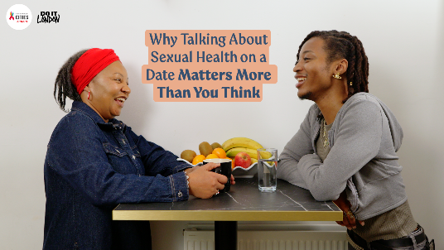  https://youtu.be/C0wJsFFKbLI?si=Wo0UCxXMErpma5yr
FB/Instagram | “If you’re interested, you’ll do the homework”  Rebecca knows the value of having *that* conversation. But she’s not here to educate people stuck in the past.  Outdated ideas? You’re not my person.  Curious and open-minded? Great — but as Chisea says: “Go work yourself.”  This World AIDS Day, we’re celebrating the power of speaking up, challenging stigma, and knowing your status.  🎥 Watch the video to hear their take.  And for more about HIV, head to our site via the link in our bio.  #WorldAIDSDay #DoItLondon #HIVAwareness #SexualHealthMatters #TalkAboutIt #KnowYourStatus | 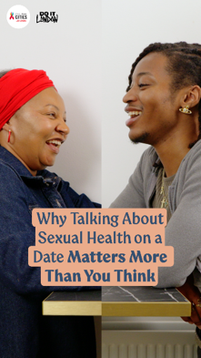
X/ Twitter | Sexual health. Some people get it. Some… get defensive (🚩). As Chisea says: “Goodbye.” 👋  Younger people might be more open to talking about sexual health— but HIV testing rates are dropping.  This #WorldAIDSDay, know your status — book a free HIV test: TOSD.shl.uk | 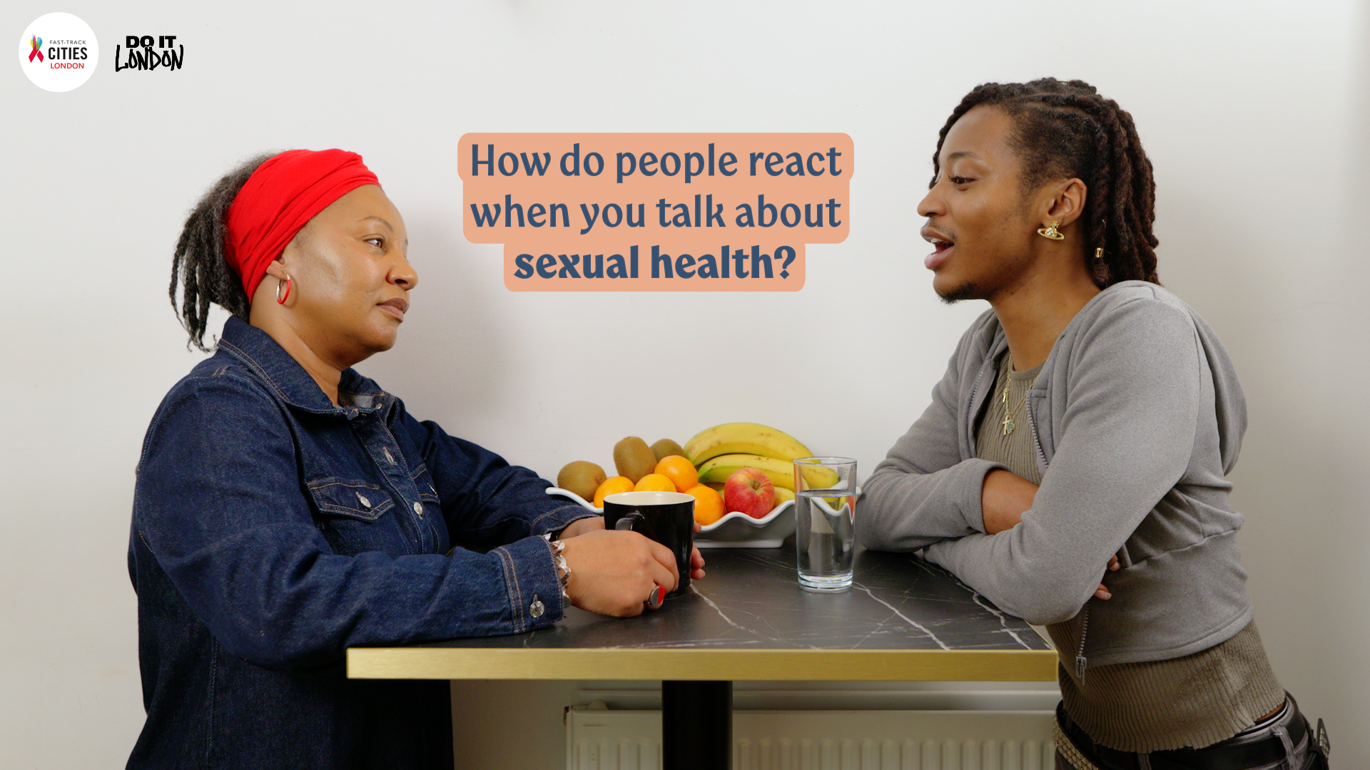  https://youtu.be/Hq8e4wwLz7M?si=Hi0h7GWm3LPPU_EU
FB/Instagram | Bringing up sexual health.  Some people get it. Some… get defensive (🚩). But as Chisea says, if that’s the case: “Goodbye.” 👋  Talking about sexual health shouldn’t be weird. And maybe the younger generation are more open – but there’s still plenty of work to do, with testing levels for HIV dropping among younger people.  This World AIDS Day, we’re celebrating open conversations, strong boundaries and ditching the stigma.  ✅ Start with knowing your status — book a free HIV test today. Link in our bio.  #WorldAIDSDay #DoItLondon #HIVAwareness #SexualHealthMatters #TalkAboutIt #KnowYourStatus #HIVTesting | 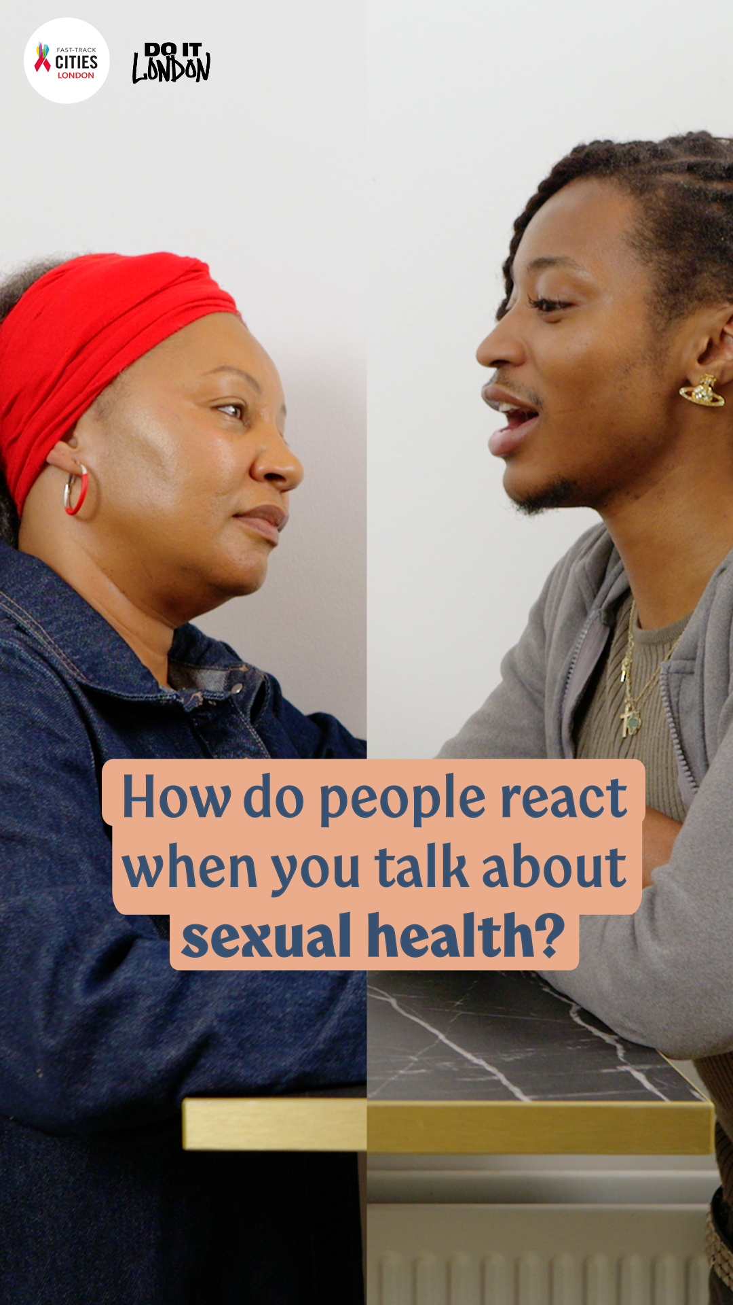
X/ Twitter | Rebecca used to worry about sharing her HIV status — now she’s got a technique (even if it flies over some heads 😂).  From anxiety to confidence, she owns it.  This #WorldAIDSDay, we’re celebrating dating without stigma.  🔗 Learn more at doitlondon.org | 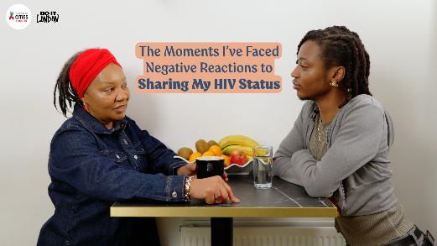  https://youtu.be/S28L_0u8quw?si=f37vHfKm5R5gyo7B
FB/Instagram | “It’s taken years to be able to do that”  Rebecca shares how worrying about when to bring up her HIV status used to take the joy out of dating.  Now? She’s got a technique — though people aren’t always quick on the uptake 😂  From anxiety to confidence, Rebecca’s journey shows how owning your status can shift the power back to you.  This World AIDS Day, we’re celebrating self-assurance, smart tactics and the freedom to enjoy dating without stigma.  For more about HIV, head to our site via the link in our bio.  #WorldAIDSDay #DoItLondon #HIVAwareness #SexualHealthMatters #KnowYourStatus #TalkAboutIt #DatingWithConfidence | 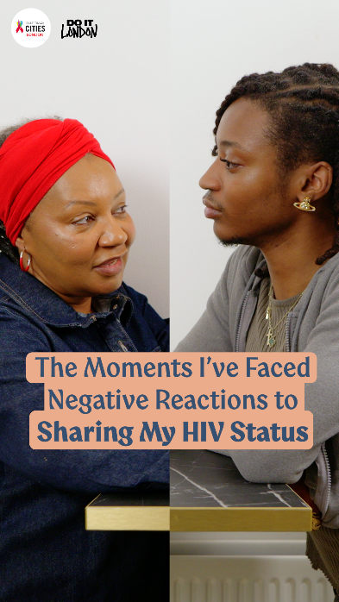

Testing, Protecting and Preventing (General)
Channel | Post | Graphic
X / Twitter | Cleo’s here to bust the BIGGEST myths around sexual health 👊  This #WorldAIDSDay, let’s talk facts — not fear.  ✅ Book a free HIV test today: TOSD.shl.uk  #DoItLondon #HIVAwareness #SexualHealthMatters #KnowYourStatus #MythBusting | 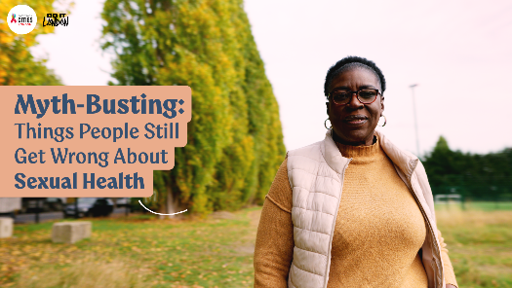  https://youtu.be/EjgwhydcYvA?si=X2ugE-PRCXXMBszG
X / Twitter | We’re lucky to live in a time where HIV treatment means long, healthy lives. But late diagnosis can still impact your health. The fix? Test. It’s free, quick & confidential. Do it at least once a year for peace of mind.  👉 TOSD.shl.uk  #WorldAIDSDay | 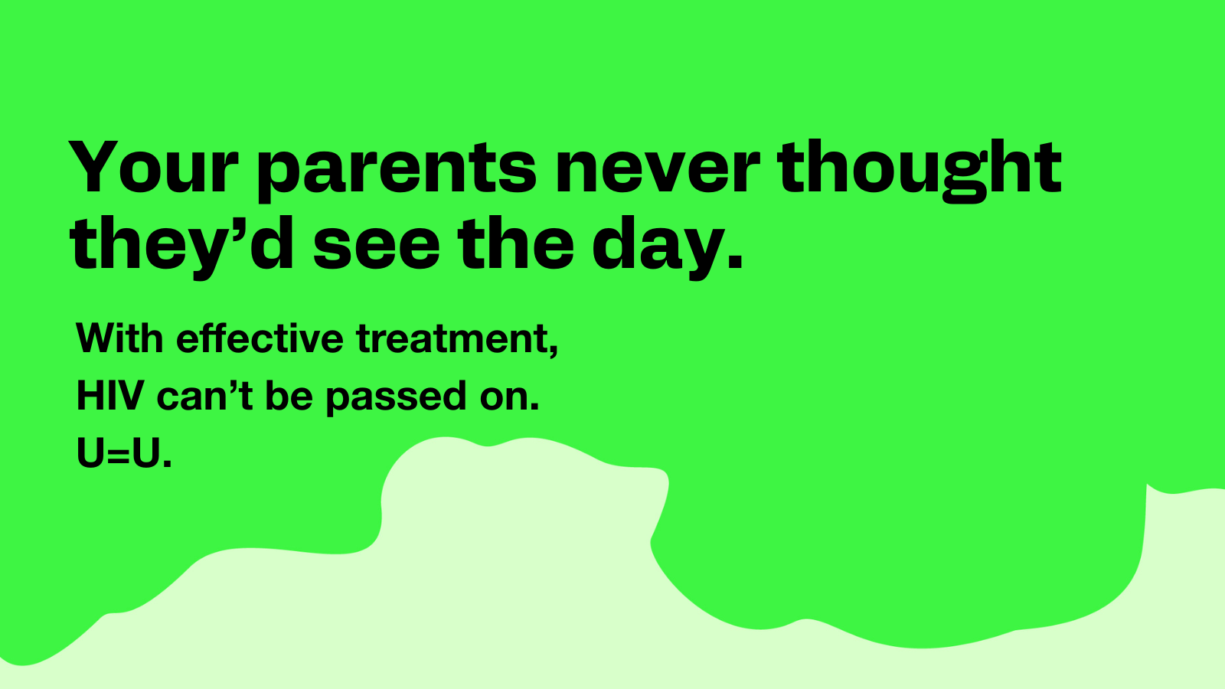
X / Twitter | HIV testing is free, easy & confidential — and gives you peace of mind. Everyone should test at least once a year, and World AIDS Day is the perfect reminder. Order online or visit your local clinic.  👉 TOSD.shl.uk  #WorldAIDSDay #HIVTesting | 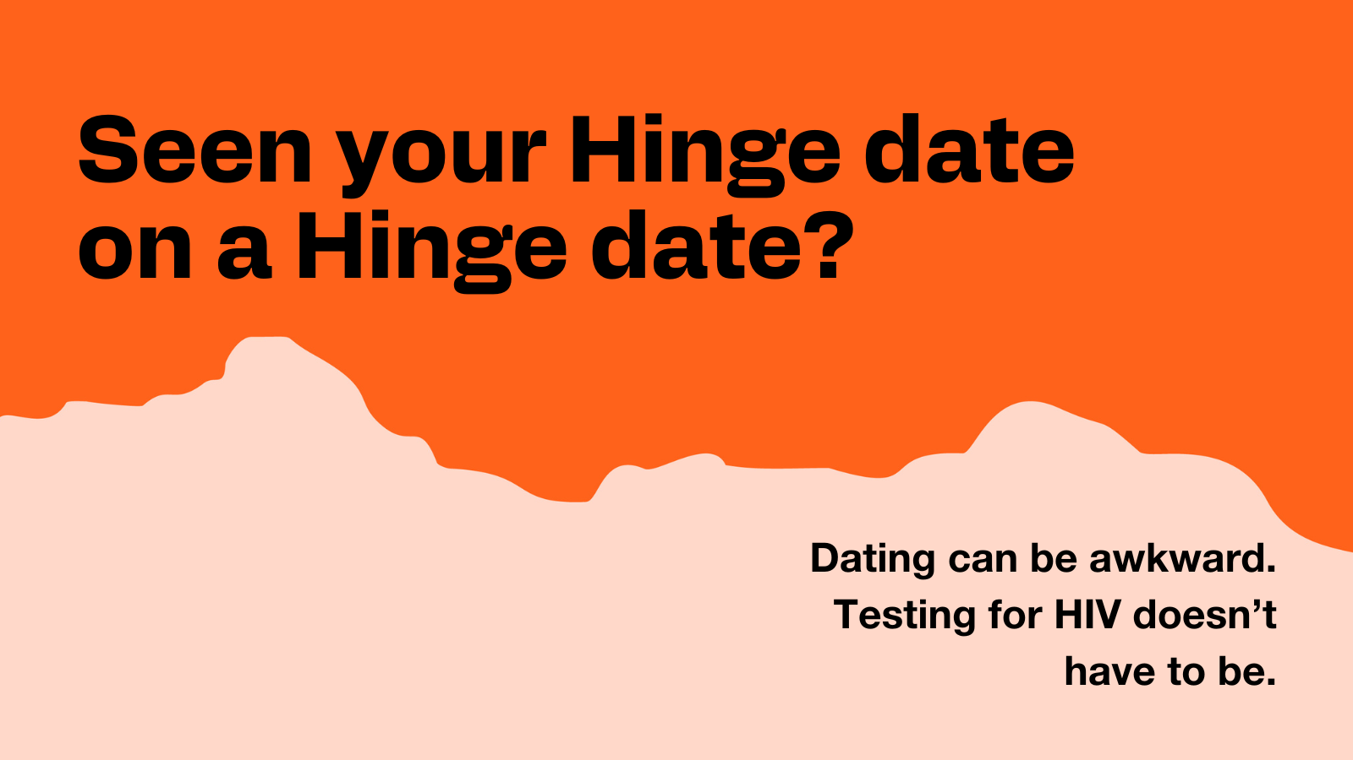
X / Twitter | Dating, hooking up or just living your best life? PrEP has your back. 💊  This World AIDS Day, take control of your sexual health. Find out if PrEP is right for you at doitlondon.org and protect yourself with confidence.  #PrEP #WorldAIDSDay #HIVPrevention | 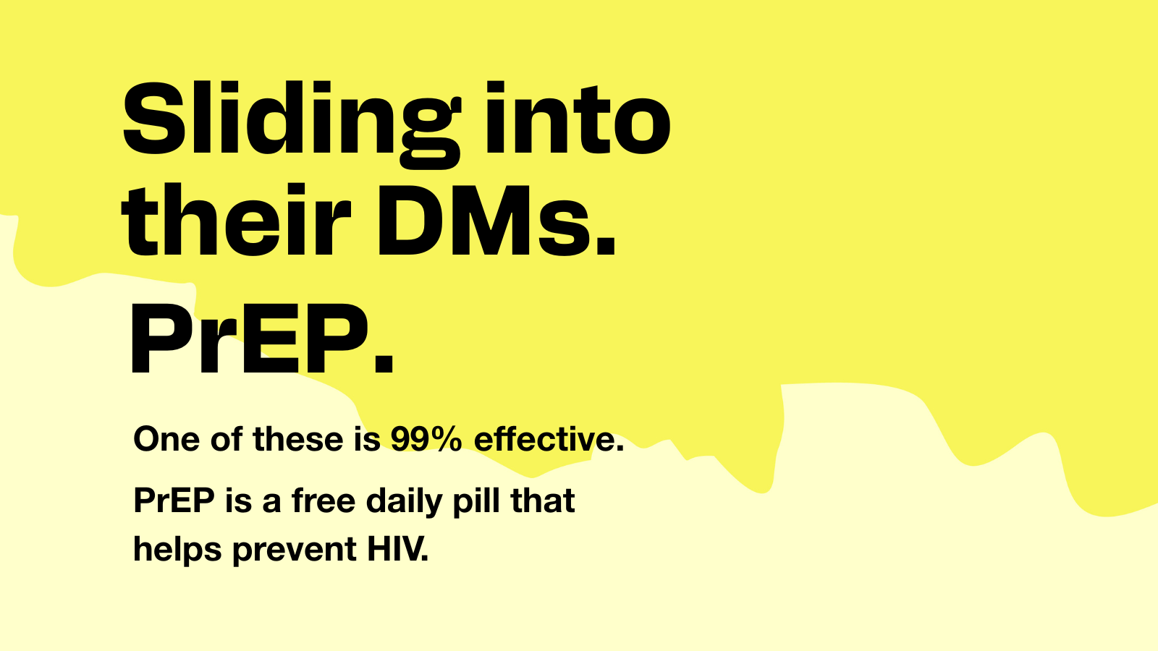
X / Twitter | U=U: Undetectable = Untransmittable. People on effective HIV treatment can’t pass it on — and can live long, healthy lives 🧡  This is your reminder to test at least once a year. It’s free, easy & confidential.  👉 TOSD.shl.uk  #WorldAIDSDay | 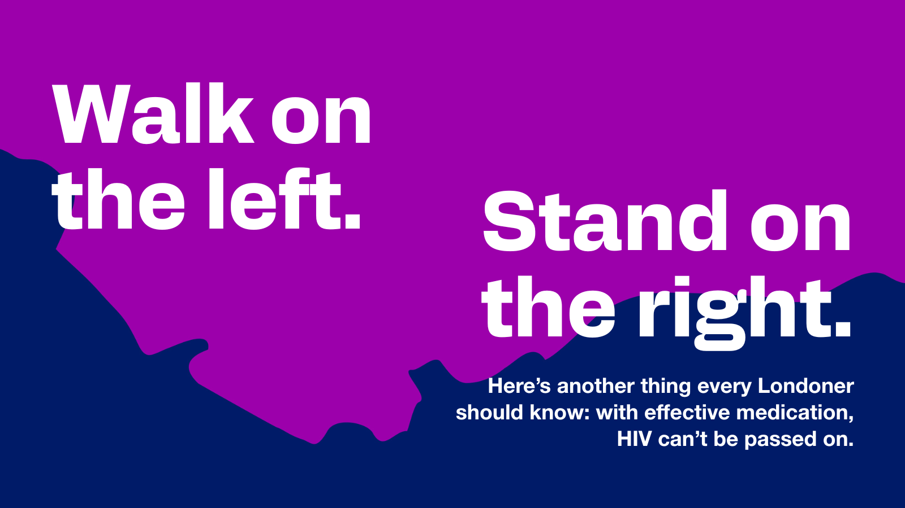
FB/Instagram | “You don’t need to test because you feel fine?”  👀 Think again.  Cleo’s here to bust some of the BIGGEST myths around sexual health — because misinformation is so last decade.  🎥 This World AIDS Day, she’s setting the record straight.  Let’s talk facts, not fear. Let’s talk about testing, protection and knowing your status.  ✅ Ready to get clued up? Book a free HIV test — link in bio.  #WorldAIDSDay #DoItLondon #HIVAwareness #SexualHealthMatters #MythBusting #KnowYourStatus #STIAwareness | 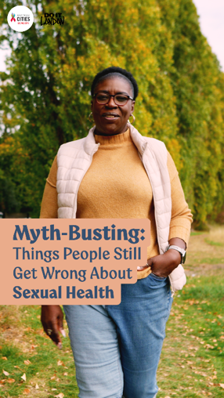
FB/Instagram Post | Your parents never thought they’d see the day — but here we are 💪  We’re fortunate to live in a time where, with the right (FREE) medication, people living with HIV can lead long, healthy lives. ️  This World AIDS Day, we’re celebrating how far treatment has come — but we’re also raising awareness of late diagnosis. That’s when HIV is found after it’s already started to impact your health.  How do you stop late diagnosis? The good news is it’s easy – you test. Testing is free, quick and confidential. Getting on top of a diagnosis early means you can get the care you need to stay well. And if your test is negative, you have peace of mind.  Test at least once a year — it’s one of the best things you can do for your health.  Order a test from doitlondon.shl.uk today.  #DoItLondon #WorldAIDSDay #UequalsU #HIVTestWeek #TestReady | 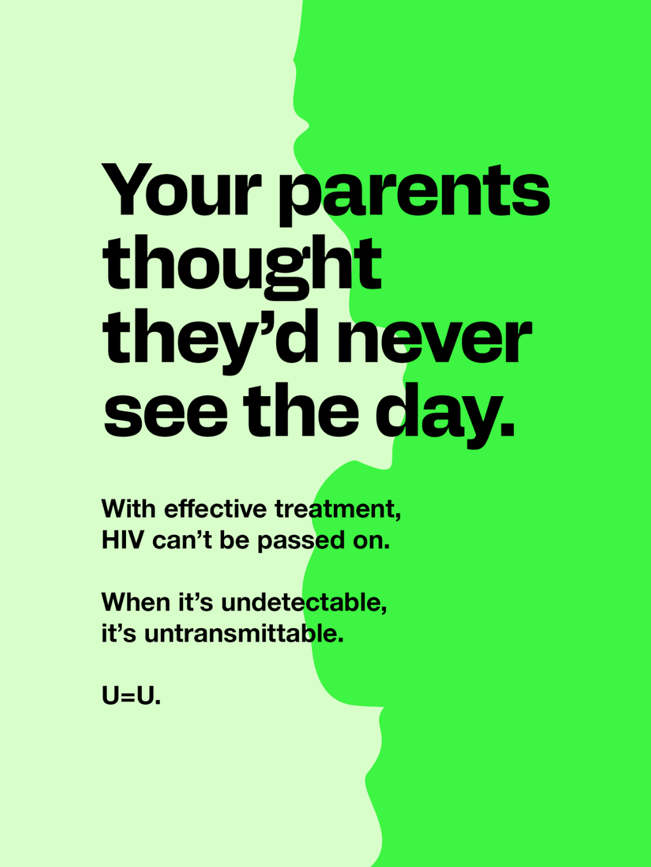
FB/Instagram Post | Dating can be awkward, but protecting your health doesn’t have to be.  Testing for HIV is free, easy, confidential – and can give you peace of mind. Everyone should test at least once a year, and World AIDS Day is the perfect reminder.  Order a test online at doitlondon.shl.uk or get a test at a local sexual health clinic.  #HIV #HIVProtection #HealthyLondon #HIVtesting #WorldAIDSday | 
FB/Instagram Post | PrEP is a free daily pill that helps prevent HIV — and it’s a total game-changer. Whether you're dating, hooking up, or just living your best life, PrEP has your back.  This World AIDS Day, take control of your sexual health. Go to doitlondon.org to find out if PrEP is right for you and protect yourself with confidence. 💊  #DoItLondon #PrEP #HIVPrevention #WorldAIDSDay #SexualHealthMatters | 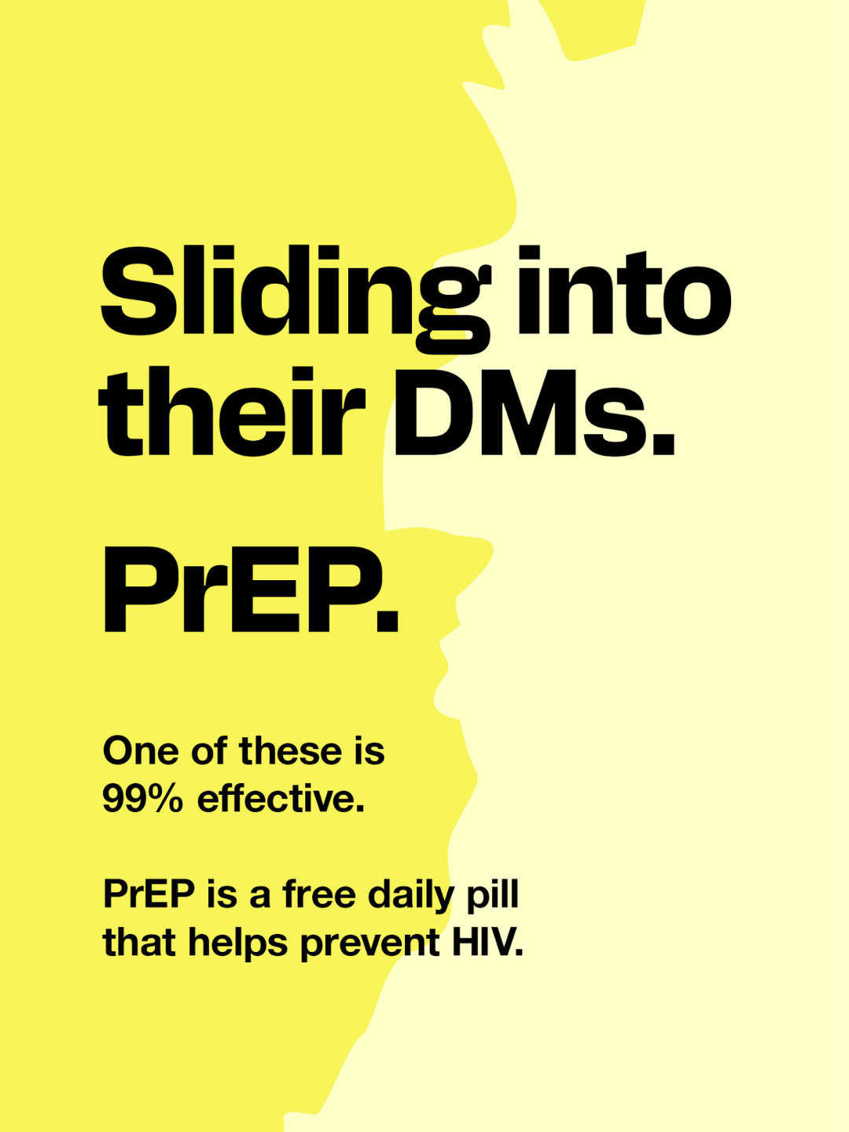
FB/Instagram Post | It’s called U=U — undetectable = untransmittable.  That means people living with HIV who are on treatment and have an undetectable viral load cannot pass it on to partners. This treatment also means people can lead long, healthy lives living with HIV.  It’s one of the most important facts to know — and share — this World AIDS Day.  Everyone should test at least once a year, and World AIDS Day is the perfect reminder.  Order a test online at doitlondon.shl.uk or get a test at a local sexual health clinic.  #DoItLondon #UequalsU #WorldAIDSDay #HIVAwareness #LondonUnderground #CommuterLife #TestReady | 